**Exercise 1: Configuring a Basic Spring Application**

**File: Main.java**

package com.library;

import com.library.service.BookService;

import org.springframework.context.ApplicationContext;

import org.springframework.context.support.ClassPathXmlApplicationContext;

public class Main {

public static void main(String[] args) {

ApplicationContext context = new ClassPathXmlApplicationContext("applicationContext.xml");

BookService bookService = (BookService) context.getBean("bookService");

bookService.addBook();

}

}

**File: BookService.java**

package com.library.service;

import com.library.repository.BookRepository;

public class BookService {

private BookRepository bookRepository;

public void setBookRepository(BookRepository bookRepository) {

this.bookRepository = bookRepository;

}

public void addBook() {

System.out.println("Spring in Action");

bookRepository.saveBook();

}

}

**File: BookRepository.java**

package com.library.repository;

public class BookRepository {

public void saveBook() {

System.out.println("Spring in Action");

}

}

**File: applicationContext.xml**

<?xml version="1.0" encoding="UTF-8"?>

<beans xmlns="http://www.springframework.org/schema/beans"

xmlns:xsi="http://www.w3.org/2001/XMLSchema-instance"

xsi:schemaLocation="http://www.springframework.org/schema/beans

http://www.springframework.org/schema/beans/spring-beans.xsd">

<bean id="bookRepository" class="com.library.repository.BookRepository"/>

<bean id="bookService" class="com.library.service.BookService">

<property name="bookRepository" ref="bookRepository"/>

</bean>

</beans>

**File: pom.xml**

<project xmlns="http://maven.apache.org/POM/4.0.0"

xmlns:xsi="http://www.w3.org/2001/XMLSchema-instance"

xsi:schemaLocation="http://maven.apache.org/POM/4.0.0

http://maven.apache.org/xsd/maven-4.0.0.xsd">

<modelVersion>4.0.0</modelVersion>

<groupId>com.library</groupId>

<artifactId>LibraryManagement</artifactId>

<version>1.0-SNAPSHOT</version>

<packaging>jar</packaging>

<name>LibraryManagement</name>

<properties>

<project.build.sourceEncoding>UTF-8</project.build.sourceEncoding>

</properties>

<dependencies>

<dependency>

<groupId>org.springframework</groupId>

<artifactId>spring-context</artifactId>

<version>5.3.34</version>

</dependency>

</dependencies>

</project>

**OUTPUT:**

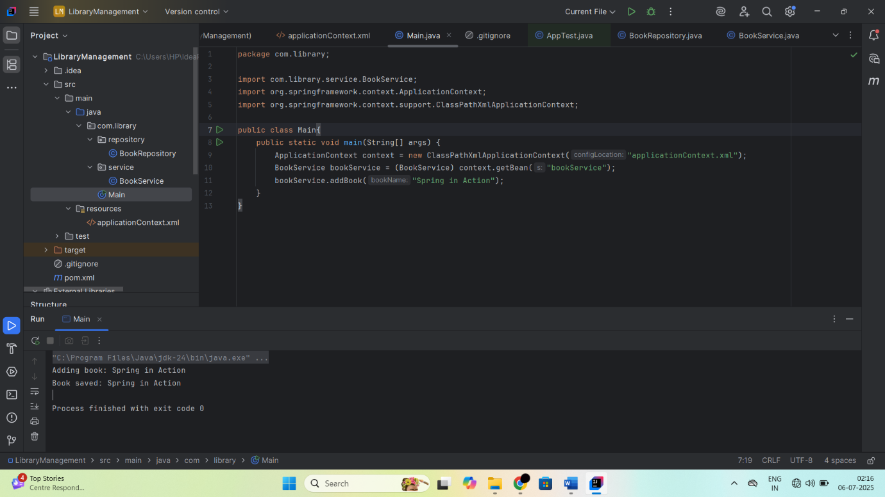

**Exercise 2: Implementing Dependency Injection**

**File: LibraryManagementApplication.java**

package com.library;

import com.library.service.BookService;

import org.springframework.context.ApplicationContext;

import org.springframework.context.support.ClassPathXmlApplicationContext;

public class LibraryManagementApplication {

public static void main(String[] args) {

ApplicationContext context = new ClassPathXmlApplicationContext("applicationContext.xml");

BookService bookService = (BookService) context.getBean("bookService");

bookService.addBook();

}

}

**File: BookService.java**

package com.library.service;

import com.library.repository.BookRepository;

public class BookService {

private BookRepository bookRepository;

public void setBookRepository(BookRepository bookRepository) {

this.bookRepository = bookRepository;

}

public void addBook() {

System.out.println("Spring in Action");

bookRepository.saveBook();

}

}

**File: BookRepository.java**

package com.library.repository;

public class BookRepository {

public void saveBook() {

System.out.println("Spring in Action");

}

}

**File: applicationContext.xml**

<?xml version="1.0" encoding="UTF-8"?>

<beans xmlns="http://www.springframework.org/schema/beans"

xmlns:xsi="http://www.w3.org/2001/XMLSchema-instance"

xsi:schemaLocation="http://www.springframework.org/schema/beans

http://www.springframework.org/schema/beans/spring-beans.xsd">

<bean id="bookRepository" class="com.library.repository.BookRepository"/>

<bean id="bookService" class="com.library.service.BookService">

<property name="bookRepository" ref="bookRepository"/>

</bean>

</beans>

**File: pom.xml**

<project xmlns="http://maven.apache.org/POM/4.0.0"

xmlns:xsi="http://www.w3.org/2001/XMLSchema-instance"

xsi:schemaLocation="http://maven.apache.org/POM/4.0.0

http://maven.apache.org/xsd/maven-4.0.0.xsd">

<modelVersion>4.0.0</modelVersion>

<groupId>com.library</groupId>

<artifactId>LibraryManagement</artifactId>

<version>1.0-SNAPSHOT</version>

<packaging>jar</packaging>

<name>LibraryManagement</name>

<properties>

<project.build.sourceEncoding>UTF-8</project.build.sourceEncoding>

</properties>

<dependencies>

<dependency>

<groupId>org.springframework</groupId>

<artifactId>spring-context</artifactId>

<version>5.3.34</version>

</dependency>

</dependencies>

</project>

**OUTPUT:**

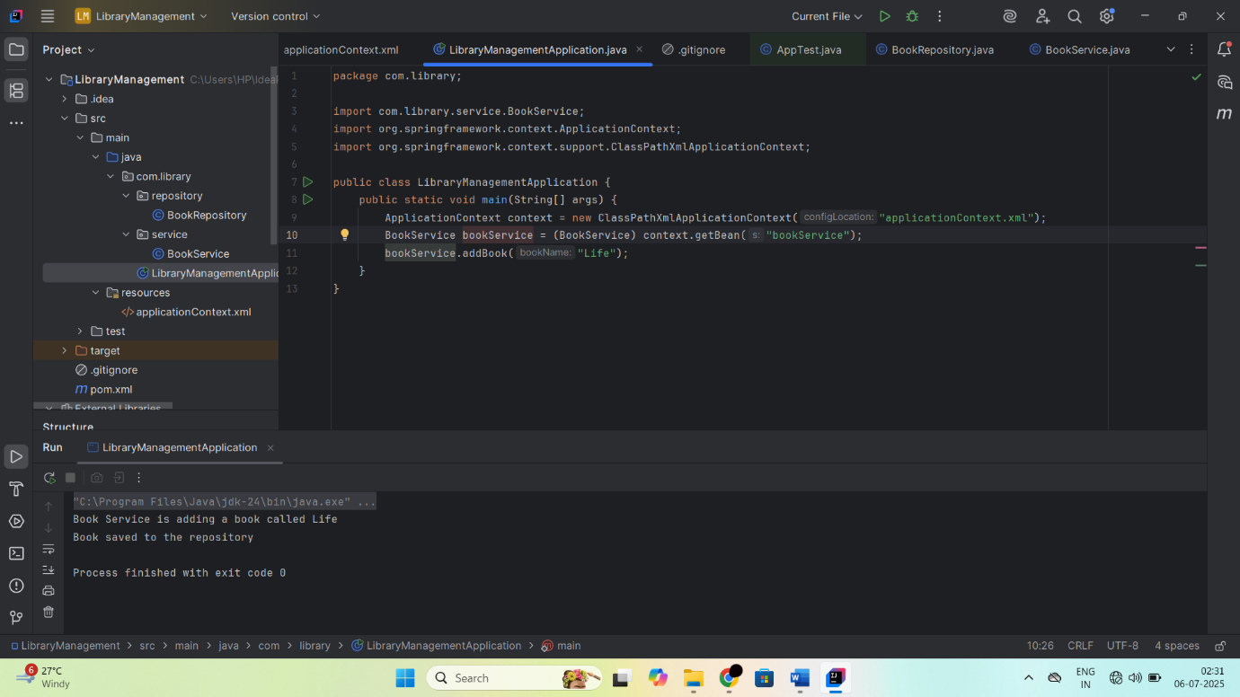

**Exercise 4: Creating and Configuring a Maven Project**

package com.library.repository;

public class BookRepository {

public void saveBook(String bookName) {

System.out.println("Saving book: " + bookName);

}

}

package com.library.service;

import com.library.repository.BookRepository;

public class BookService {

private BookRepository bookRepository;

public void setBookRepository(BookRepository bookRepository) {

this.bookRepository = bookRepository;

}

public void addBook(String bookName) {

System.out.println("Adding book: " + bookName);

bookRepository.saveBook(bookName);

}

}

package com.library;

import com.library.service.BookService;

import org.springframework.context.ApplicationContext;

import org.springframework.context.support.ClassPathXmlApplicationContext;

public class Main {

public static void main(String[] args) {

ApplicationContext context = new ClassPathXmlApplicationContext("applicationContext.xml");

BookService bookService = (BookService) context.getBean("bookService");

bookService.addBook("Clean Code");

}

}

<?xml version="1.0" encoding="UTF-8"?>

<beans xmlns="http://www.springframework.org/schema/beans"

xmlns:xsi="http://www.w3.org/2001/XMLSchema-instance"

xsi:schemaLocation="

http://www.springframework.org/schema/beans

http://www.springframework.org/schema/beans/spring-beans.xsd">

<bean id="bookRepository" class="com.library.repository.BookRepository" />

<bean id="bookService" class="com.library.service.BookService">

<property name="bookRepository" ref="bookRepository"/>

</bean>

</beans>

**OUTPUT:**

